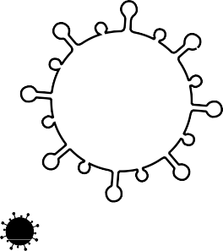

TIME CAPSULE

BY:

YOU ARE LIVING THROUGH HISTORY RIGHT NOW

TAKE A MOMENT TO FILL IN THESE PAGES FOR YOUR FUTURE SELF TO LOOK BACK ON. AND HERE ARE SOME OTHER IDEAS OF THINGS TO INCLUDE:

SOME PHOTOS FROM THIS TIME A JOURNAL OF YOUR DAYS
LOCAL NEWSPAPER PAGES OR CLIPPING
ANY ART WORK YOU CREATED FAMILY / PET PICTURES
SPECIAL MEMORIES

DRAW A PICTURE OF THE PEOPLE YOU ARE SOCIAL DISTANCING WITH HERE

DATE:

MY FAVORITES

YEARS OLD

TOY:

COLOR:

ANIMAL:

FOOD:

INCHES TALL

SHOW:

MOVIE:

BOOK:

ACTIVITY:

POUNDS

PLACE:

SONG:
WHEN I GROW UP I WANT TO BE:

MY BEST FRIEND/S:

WHAT I HAVE LEARNED MOST FROM THIS EXPERIENCE:

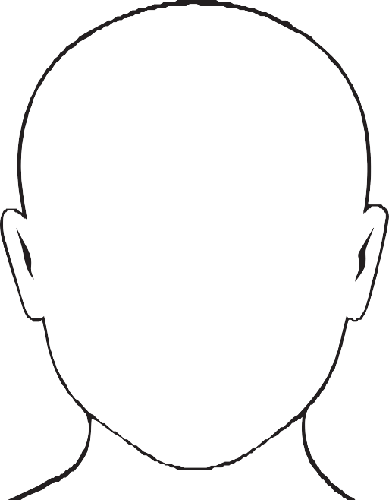
WORDS TO DESCRIBE HOW I FEEL:
HOW MY FACE LOOKS

I AM MOST THANKFUL FOR

THE 3 THINGS I AM MOST EXCITED TO DO WHEN THIS IS OVER:
1
2
3

WHERE I AM LIVING DURING THIS TIME:

WHAT THINGS ARE YOU DOING TO HELP FEEL CONNECTED/HAVE FUN
OUTSIDE (e.g hearts in windows, chalk notes on sidewalk, etc)

HOW ARE YOU CONNECTING WITH OTHERS?

YOU ARE NOT STUCK AT HOME,
YOU ARE SAFE AT HOME!

WHAT I AM DOING TO KEEP BUSY:

PRINT THE HANDS OF ALL THE PEOPLE LIVING IN YOUR HOME (IN DIFFERENT COLORS) AND PLACE YOUR HANDS HERE

WHAT OCCASIONS DID YOU CELEBRATE DURING THIS TIME?
WRITE THE LIST DOWN HERE AND WHAT YOU DID TO CELEBRATE (E.G. ST. PATRICK’S DAY, EASTER, BIRTHDAYS, ANNIVERSARIES)

EVENT | DATE | HOW YOU CELEBRATED

DEAR,

LOVE,

I NTERVIEW YOUR HOUSEHOLD

WHAT HAS BEEN THE BIGGEST CHANGE?

HOW ARE YOU FINDING HOMESCHOOLING?

DAYS SPENT INSIDE

YOUR TOP 3 MOMENTS FROM THIS EXPERIENCE:
HOW ARE YOU FEELING?
1.
2.
3.

WHAT ACTIVITIES/HOBBIES HAVE YOU MOST ENJOYED DOING?
WHAT ARE YOU MOST THANKFUL FOR?

WHAT TV SHOW YOU WATCHED : YOUR NEW FOUND FAVORITE INSIDE HOUSEHOLD ACTIVITY:

FAVORITE FOOD TO BAKE: FAVORITE TIME OF DAY:
GOAL/S FOR
AFTER THIS:

LETTER FROM YOUR HOUSEHOLD

DEAR,

LOVE,

