MIDLAND ELEMENTARY
PHYSICAL EDUCATION
“ABBRIVIATED SELF FITNESS TEST” 2020
&
“GET UP & MOVE” 2020

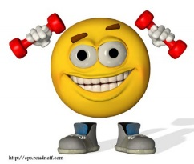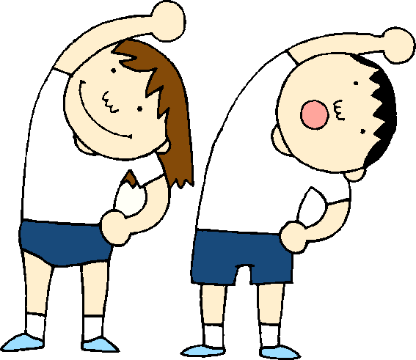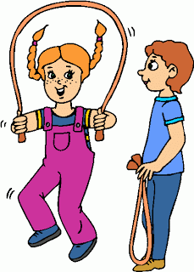

Dear Parents,
First, I hope all of you are doing well, staying safe, and above all finding some way to stay active for yourself and with your children. I know I am spending days lifting weights at home, running, walking my dogs, going fishing, and what I enjoy is yard work. But, I hope you are doing a lot of these outdoor activities together, and what a great family thing to be doing during these challenging times. So with that being said;

Parents, I need your help with my assignment that I will be giving to your child. Now since this is fitness related, I cannot hold this against them if they are not able to complete it, but I am hoping they can complete all 3 fitness areas and their journal, and for this I will award them an (E) for Excellent or, an (S) for at least attempting 1 or 2 of the fitness areas, plus journal . These activities will count toward their 4th 9 weeks PE grade. So, let’s have fun staying fit and enjoying this time with family and know that you are staying healthy and safe.

Starting the week of May 4, 2020, and ending May 8, 2020, I would like for your child to do 2 activities:

- I HAVE ENTITLED THIS JOURNAL TO BE: “GET UP AND MOVE”
You can make up your own journal using loose leaf paper, or you can use a small spiral notebook to write down what you did physically throughout each day. If you could, do this before you get ready for bed. Here is an example: April 27th, 2020, Journal entry #1; I had an overall pretty good active day today. After waking up and having something for breakfast, I was able to go out and ride my bike with some friends for about an hour or so. Billy had a basketball rim, so we both took turns shooting some ball. We were both safe and made sure we stayed 6 feet apart while shooting. After I got home around lunch time, I made sure I washed my hands real well, and grabbed an orange for lunch. After Lunch, I was able to go out in our driveway to Jump some rope and play with our dog chasing him around the yard. Boy is he fast! My brother and sister came out and we all played a tag game which was fun especially when mom and dad wanted to play. So, today was a lot of fun, and I felt good staying active.
(You can make your entries as detailed as you would like, just let me know what you did)

JOURNAL ASSIGNMENT DUE DATE: May 9th or when you turn your packet in for that week for Mrs. Wamsley, and Mrs. Robinson.

- ABBRIVATED SELF FITNESS TEST – (3 parts, Cardiovascular, flexibility, and strength)

- Part 1 - CARDIOVASCULAR TEST - Parents, please help by finding a safe place to do this by measuring off somehow a mile in length. This could be in your neighborhood, or if Glendale park is open (keeping your social distancing, that trail lap is almost 1 mile around), Elkins high school track.

2 Options with this one; (CHOOSE ONLY 1)
Option 1: Walk Mile, but you must walk ONLY at your fastest walk pace only. A parent must time you while you do this.
Option 2: Run/Walk, again a parent must time you.

ASSIGNEMENT DUE: Record your final time sometime that week of May 18th, 2020. (Include a page in your journal for Fitness Test)

- Part 2 – SHOULDER FLEXIBILITY TEST - A parent must verify you are doing this correctly. You will write down Y - Yes or N - No for both your Right and Left side. You raise your Right hand and place it behind your head, and put your right hand on your back. You then take your Left hand and put it behind your back and try and touch finger tips of your right hand. If you touch finger tips, (Record Right side Y). If you cannot touch finger tips, (Record Right side N). Then repeat above for your Left side. A Parent must verify.

ASSIGNEMENT DUE: Record your final attempt in your Journal the Week of May 18th, 2020. I would suggest you stretch your shoulders daily, especially if you cannot touch your fingertips. Some of you will be able to touch on both sides with no trouble, but some may need daily practice. So this is why I suggest waiting until that week to Record your results.

C). Part 3 – SHOULDER STRENGTH – (They cannot do a modified or girl pushup) A Parent must watch and verify you are doing these correctly. Set up. Find something soft that is approximately 2 inches high, or stack up some small books that are 2 inches high, or your parent can use their fist by placing it on the floor or ground underneath your chest. When you go down bending your arms, your chest must touch this object, before pushing back up to count as 1 push-up. You cannot do 1, then rest and then add to it. You are allowed to rest, but when you begin again, you must start at 0.

PARENTS MUST WATCH FOR: (If any of these problems happen after they begin, then stop them and you cannot count that push up).
- Their chest does not touch the object under them, stop them.
- As you watch them go down, if you see their HIPS fall below a straight line, stop them.
- And if you see their HIPS raise up above a straight line, stop them.

ASSIGNEMENT DUE: They have time to practice daily, I would suggest recording their final attempt May 8th and add results to their journal.

Do the best you can, and Happy moving.
Mr. Price

