Summer Reading in the Park

Monday-Thursday

July 9th-12th

4:00-5:30

Midland Elementary Playground

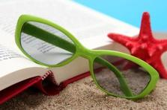

Students please join us this summer for books, crafts and snacks at the Midland Playground Pavilion

July 9th: Read Alouds and Puffer Fish Craft with a snack

July 10th: Read Alouds and Oceans in a Bottle Craft with a snack

July 11th: Read Alouds and Jellyfish Craft with a snack

July 12th : Read Alouds and Crabs Craft with a snack

Students will receive a **Free Book** Each Evening

Mrs. Burke,

Mrs. Riggins,

Mrs. Robinson