Announcing…..

**“Readers Are Leaders”**

2018 Summer Library Reading Challenge

Midland Elementary

***Are you up for the challenge?***

All K-5th grade students who visit the school library on Wednesdays during the summer and meet their grade level goal will attend a trip to the bowling alley.

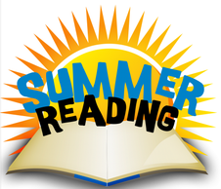

**Goals:**

**Kindergarten, 1st and 2nd grade: 15 books or 4 AR points**

**3rd grade students: 5 AR points**

**4th grade students: 7 AR points**

**5th grade students: 9 AR points**

***Computers will be available for students to take quizzes each Wednesday listed below.***

***Teachers will be available to read to K-2 students during the library hours.***

**Summer Library Hours**

Wednesday, June 20th 2-3pm and 6-7 pm

Wednesday, June 27th 2-3 pm and 6-7 pm

Wednesday, July18th 2-3 pm and 6-7 pm

Wednesday, July 25th 2-3 pm and 6-7 pm